Chennai-602105


SIMATS ENGINEERING
Saveetha Institute of Medical and Technical Sciences
Chennai-602105

CSA0311-DATA STRUCTURES
CO1-ASSESMENT TOOL
OUTPUT PREDICTION

NAME:K.Mosikiran
REG NO:192511353
COURSE:Data structures
COURSE CODE:CSA0311
DATE OF SUBMISSION:24/07/2026

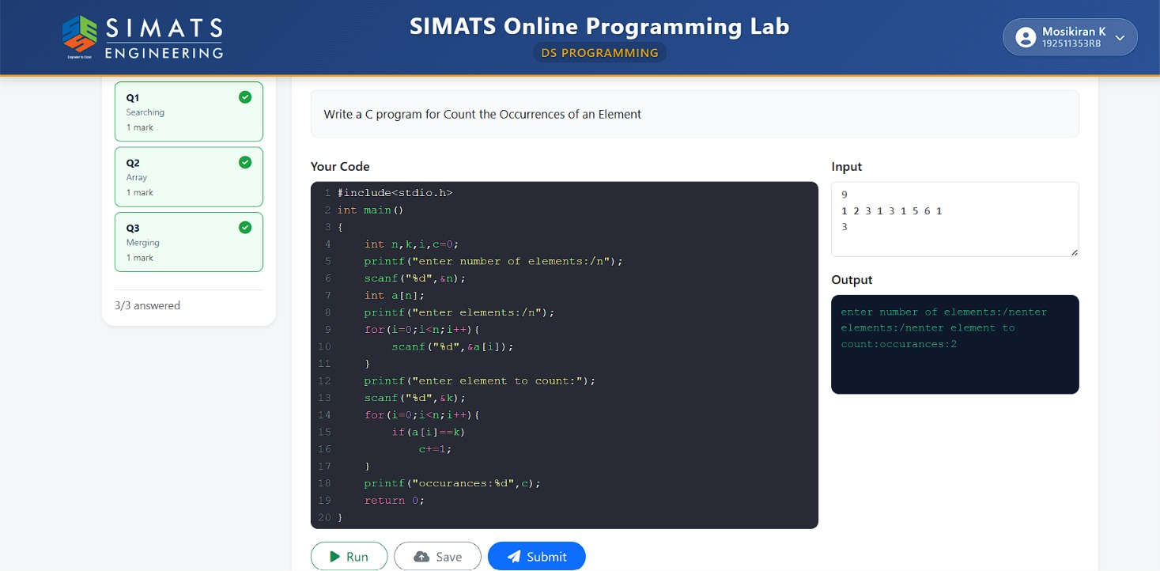
Q1. COUNT THE OCCURENCES OF AN ELEMENT.

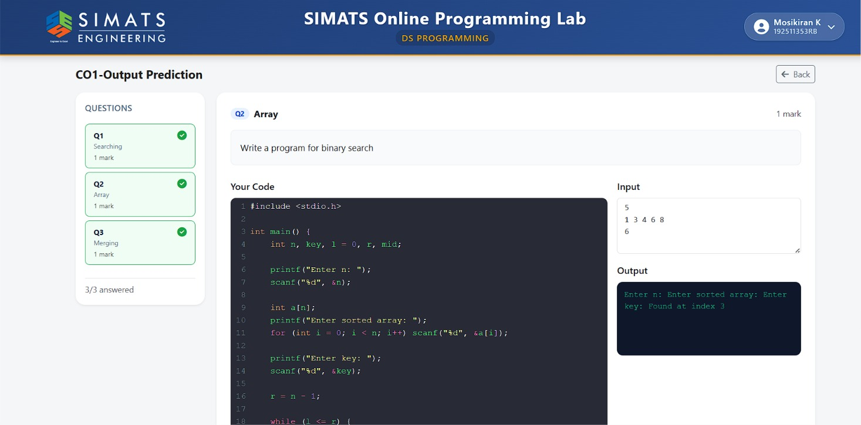
Q2.BINARY SEARCH.
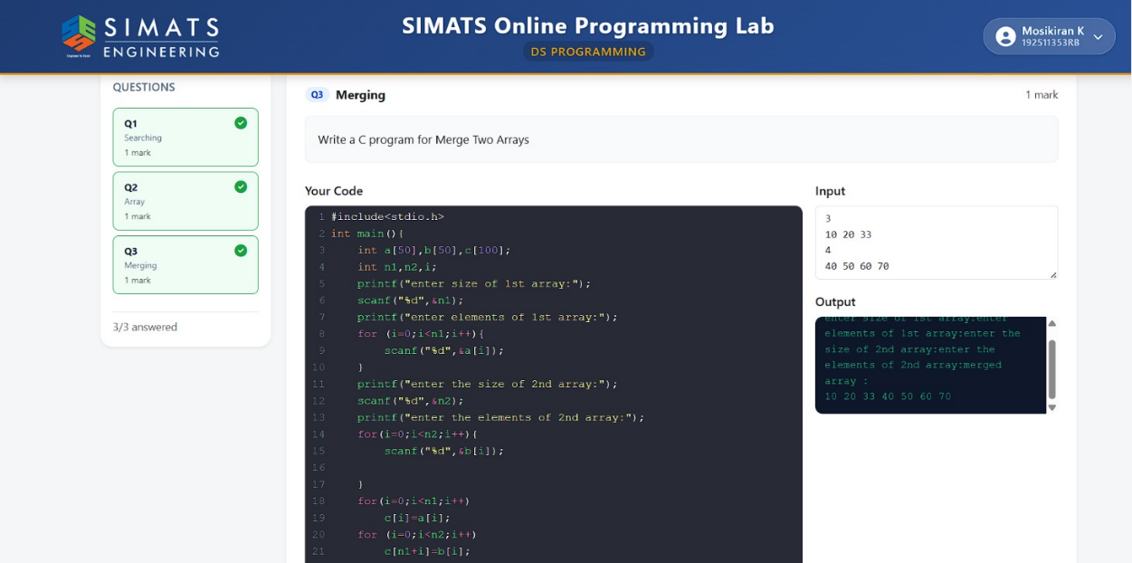
Q3.MERGE TWO ARRAYS

